STUART SCOTT

Email: stuart.h.scott@gmail.com
U.S. mobile: +1.808.392.5188
Skype ID: StuartGaia

Curriculum Vitae
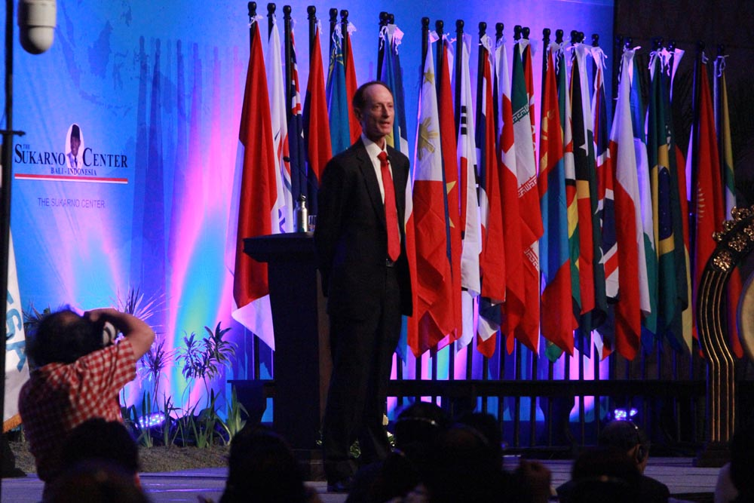
My career has changed over the years from an employment-based, conventional paradigm to a service-based one, reflecting a decision to give up money as organizing principle in my life. In its place, I adopted the goal of helping restore ecological balance by leveraging social, economic, academic, diplomatic and government institutions. Having identified the root of our ecological imbalance, I focus on educational and action-oriented interventions to create the shifts immanently required for sustainability and the survival of humanity in the 21st century. My career thus divides into two phases, with most recent entries indicated as open-ended initiatives.

Career of Service

United Planet Faith & Science Initiative (UPFSI.org), January 2012 - Onward. Based upon prior work on the Interfaith Declaration on Climate Change (interfaithdeclaraion.org) and The Climate Summit, detailed below, I founded this initiative to create a coalition of two of the most powerful forces in society today, Science and Faith (religion). The UPFSI aims at changing the attitudes and actions of humanity and is devoted to saving the climate, biodiversity, and ecosystems of Earth for future generations.

The Climate Matters Show (ClimateMatters.TV), December 2014 - Onward. My attendance at the annual UN-sponsored Conference of Parties to the Kyoto Protocols (COPs) spawned a specialization in creating topical press conferences aimed at promoting global awareness of the climate problem. This in turn transformed into my conducting multiple ‘press conferences’ at each COP since 2014 constituted more as TV shows than as press conferences. The UN FCCC appears to be agreeable to my repurposing of their press conference facilities since they have permitted me to stage 6 at COP-20 in Lima, 11 at COP-21 in Paris, and 14 of the Climate Matters Shows at COP-22 in Marrakesh in 2016.

Fossil Fuel Divestment, June 2014 - Onward. Attending my first college reunion 45 years after receiving my BA from Columbia University, I spoke with a classmate who was the incoming Chairman of the Board of Trustees. I was immediately struck with the opportunity that presented me as an eco-social strategist, and created a website at DivestColumbia.org, subsequently cloned into DivestUH.org for the University of Hawaii, where my son attends college. In January of 2015 the UH Board of Regents unanimously voted to investigate divestment, along with other sustainability initiatives. In 2014 I began lobbying the Norwegian Sovereign Wealth Fund, as well as Norwegian MPs and government Ministers, joining with former US Securities and Exchange Commissioner Bevis Longstreth in that effort (DivestNorway.org). In February 2015, the NSWF announced divestment from 114 fossil fuel, cement and mining companies whose business objectives and environmental practices lie in opposition to human well-being.

NagaCorp. Ltd June 2013 – October, 2014. I was hired as an ecological consultant to NagaCorp, Ltd. in July of 2013, and subsequently appointed as the first Chief Ecological Officer of a major international corporation. We worked aggressively to reduce of the company’s ecological footprint, and introduce ecological awareness into corporate culture, spreading it to other companies and our supply chain. I established the world’s first Department of Corporate Ecological Responsibility™. I hired a Sustainability Manager who continues to foster cost, energy and material savings, and have moved on.

Transition Initiatives, February 2011 - Onward. Founding branches of the international Transition Movement. Transition attempts to restore resilience to local communities, all but lost in developed nations, in anticipation of the societal challenges we face through the twin threats of climate change and ‘peak oil’, the ‘peaking’ of international oil production and the resultant economic dislocations and reverberations it continues to cause. The first transition initiative I founded was Transition Oahu, still functioning, growing, and assisting the ‘reskilling’ of people in the Hawaiian Islands. My second transition initiative is called Bali Transition, in Indonesia. The Indonesian name for this initiative is Bali Di Persimpangan, translating as ‘Bali at the Crossroads’. Spreading transition is being done through local education and the constant flow of international through this popular tourist destination.

Eco-Dharma, 2010 - 2012. As a logical progression from my climate work, I initiated a project to promote sustainability education and action in Thailand focusing on introducing organic gardens in Buddhist temples in this deeply spiritual nation. This project received an encouraging reception from both secular and religious audiences in its potential to help move Thailand away from chemical dependency in agriculture, simultaneously reducing the nation’s carbon footprint and improving local food security.

The Climate Summit, January through August 2010. Founded and directed this project (theclimatecummit.org) attempting to adapt the high-definition video-conferencing medium of telepresence to addressing the climate issue, also reducing the carbon-intensive, international air travel of conventional ‘summit’ meetings. The inaugural Climate Summit event in May, 2010 brought together educators and activists for a thought-provoking discussion of how to achieve action on the ongoing problem of climate change. While this project had a well-defined beginning and end, its legacy is the ongoing project described above as the United Planet Faith & Science Initiative.

Interfaith Declaration on Climate Change (IDCC), Spring 2009 – January 2012. I founded and directed this project combining religious leaders and scientists delivering a message the urgency of addressing climate change (interfaithdeclaration.org). The IDCC hosts press conferences at UN climate negotiations, and presented the document to the Executive Secretary on several occasions, endorsed by the Dalai Lama, Archbishop Tutu, the granddaughter of Mahatma Gandhi, and an array of other religious leaders and scientists. I obtained a handwritten message from Yvo de Boer, former UN FCCC Executive Secretary, inviting Pope Benedict to COP-15, which I personally delivered to the Vatican at a papal audience. This project has become the United Planet Faith & Science Initiative (above).

Observer Party at UN Climate Negotiations, December 2008 - Onward. Since COP-14 in Poznan, Poland I have been an accredited observer party and active participant at the intersection of science and spirituality at UN FCCC sponsored climate negotiations. I am accredited to the talks by the Abibimman Foundation, from Acra, Ghana, and am on the Board of Advisors of that NGO.

The Climate Reality Project, Spring 2007 - Onward. Having trained with the Honorable Al Gore, former Vice-President of the United States, I was given his slide set on the climate crisis. I have since then made hundreds of presentations internationally, developing thousands of additional slides. My association with Mr. Gore’s organization is ongoing.

Climate Corps, Summer 2007 - Onward. I created and am principal editor of this Internet-based vehicle for climate-related education and action. [climatecorps.org]

Prior Conventional Career

TransPacific Hawaii College, Tokai University and University of Phoenix, Honolulu, Hawaii, 2002 - 2008. As a college and university instructor I specialized in the integration of technical and humanistic knowledge, teaching students to recognize the universality of patterns in thought and behavior (both individual and group), the physical world (animate and inanimate), Nature and the Universe. I taught classes in philosophy, critical thinking, and the theory of knowledge (individual and societal patterns), mathematics (natural and cosmic patterns), statistics (societal, physical and natural patterns), and computer science (the creation of useful patterning in digital technology) at the Honolulu campuses of these colleges and universities. Student feedback always indicated high regard for this integrative approach, especially to the otherwise dry and challenging technical material.

Iolani School Art Show, Founder and Promoter, Honolulu, Hawaii, Spring 2006. Single-handedly founded, created and directed all aspects (except creation of the art) of the inaugural art show for the Iolani School, the leading college preparatory academy in Honolulu. This massive undertaking involved coordination of artists and volunteers, interfacing with conservative school administration, public relations, promotion and advertising. I personally designed and fabricated a flexible and unique modular gallery display system at minimal cost. This system is still in use by the annual art show. Show grossed $40,000 that first year, an amount not since equaled in subsequent shows.

Sunrise Technologies, Honolulu, Hawaii, 1996-2002. Part time, free-lance Information Technology (IT) consultant. 'Ground-up' implementation residential and office networks and business systems, both hardware and software, from requirements analysis through acquisition, installation, configuration, trouble-shooting, security, backup and contingency planning, end-user training and documentation.

Gaia Incorporated, Honolulu, Hawaii, 2000-2001. Founded and directed the Gaia Project, an Internet service portal supporting education and environmental causes. Managed an 8-person team, with oversight and responsibility for all areas of venture. The ‘dotcom meltdown’ killed this promising project.

Academy of the Pacific, Honolulu, Hawaii, 1996-2000. IT instructor for middle and high school students, faculty and administration. I was technology coordinator with oversight of staff and student training, system and network planning; network and systems administrator responsible for planning and implementation, configuration and capacity monitoring of Ethernet LAN and WAN interface; creator of the school’s website, webmaster and grant writer. I worked with Microsoft technology (Windows 9x/NT/2000) as well as Novell, TCP/IP, DNS, database, email and web servers.

VeriFone, Inc., Mililani, Hawaii, 1990-1996. Senior Software Engineer. I created a suite of tools for software developers, worked on operating systems, and was part of the quality assurance (QA) team.

IBM Corporation, Gaithersburg, Maryland 1985-1987 and Honolulu HI, 1987-1990. Senior Associate Programmer/Analyst on Federal Aeronautics Administration’s (FAA) Advanced Automation System, to rewrite the American air traffic control system. I correctly predicted the failure of the project based on a flaw in the analysis and underlying architecture of the approach taken. After transferring to Honolulu, Hawaii, I became a marketing representative to County, State, and Federal governments (military), for which I held a top-secret clearance. Analyzed customer requirements, configured hardware and software, arranged and coordinated new product presentations, seminars and training sessions.

University of Florida, Gainesville, Florida, 1983-1985. As graduate research assistant, developed computer simulations of electric and hybrid vehicles, managing development of software components and user-friendly interface on these early electric and hybrid vehicle simulations.

BITS Inc., New York City, NY 1980-1983. Founder of a financial systems software consulting firm. Created the nation's first check processing electronic funds transfer (EFT) system for Citicorp, and pioneered the first electronic Automated Clearing House, interfacing with major banks, clearing houses and the Federal Reserve Bank toward 'electronic check presentment', now an industry standard.

People Machine Interface, NYC, NY, 1979-1980. IT consultant and team leader on financial applications for domestic and foreign banks and service bureaus.

Merrill Lynch, NYC, NY, 1977-1978. Account Executive, and first environmentalist stockbroker on Wall Street at least 10 years before such specialization became commonplace. Representing the financial community, I testified at US Department of Energy hearings on alternative energy and energy conservation during the presidency of Jimmy Carter.

NCR Corporation, NYC, NY, 1975-1977. Demand deposit (checking) and general ledger applications.

Chemical Bank, NYC, NY, 1973-1975. Worked on a variety of financial applications for one of New York’s largest banks. Software troubleshooting, restructuring and documentation.

The Spectrum Company, Various US Cities, 1971-1973. As a musician and performance artist, I garnered experience in performance art, street theater, as well as influencing and motivating audiences.

Higher Education

University of Florida, Gainesville, FL. Master of Science in Computer & Information Science, June 1985, GPA 4.0. GRE scores: 800 Verbal, 800 Math, and 780 Analytical. 800 is the highest score attainable. Worked with compilers, artificial intelligence, and relational databases.

Columbia University, NYC, NY. Bachelor of Arts with dual major in Mathematics and Computer Science, completed in June 1969, achieving a GPA in my major studies of 3.7.

Skills, Aptitudes, Experience & Core Values

Strategist, wordsmith, communicator, educator and passionate public speaker. Intuitive, analytical, independent thinker, always focused on optimizing outcomes. Manage many projects simultaneously, as is required by the deterioration of Earth’s ecological balance. Self-starting, energetic, and resourceful in achieving goals, possessing personal wisdom, maturity and dedication to the-well being of humanity and life on Earth. Quick to adapt, clear-headed, detail-oriented, creative, perceptive, and inspired. Dedicated environmentalist and ecologist, well-founded in human psychology, able to empathize, initiate, inspire and lead. I am devoted to changing ‘business as usual’, and promoting our sustainable habitation of Earth.

